Dennis Tikhomirov. DevOps Spring’19.

Homework **Task #4 (Vagrant).**

1. Vagrant vs VirtualBox

1.1. Install VirtualBox

1.2. Install Vagrant

1.3. Create a Vagrantfile based on the box Windows 10

1.3.1. Install Windows 10 with network settings

vagrant init senglin/win-10-enterprise-vs2015community \ --box-version 1.0.0

vagrant up

Vagrantfile

Vagrant.configure("2") do |config|

config.vm.box = "senglin/win-10-enterprise-vs2015community"

config.vm.box_version = "1.0.0"

config.vm.network "public_network"

config.vm.provider "virtualbox" do |vb|

vb.gui = true

vb.memory = "1024"

end

end

Screenshot #1. Installed Win10 on VirtualBox

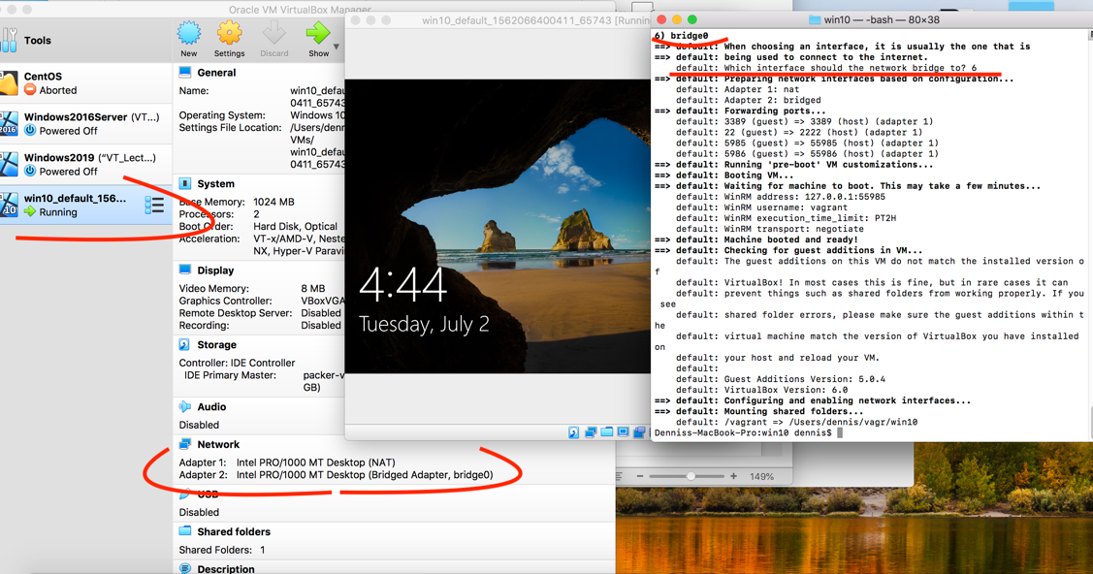

Downloading too slow !!!! <https://github.com/hashicorp/vagrant/issues/8434>

1.3.2. Connect to the box via vagrant ssh

vagrant status // show VMs

vagrant ssh default // connect to VM [default]

-sh-4.1$ systeminf // Windows command

Screenshot #2. Connect to VirtualBox VM trough Vagrant

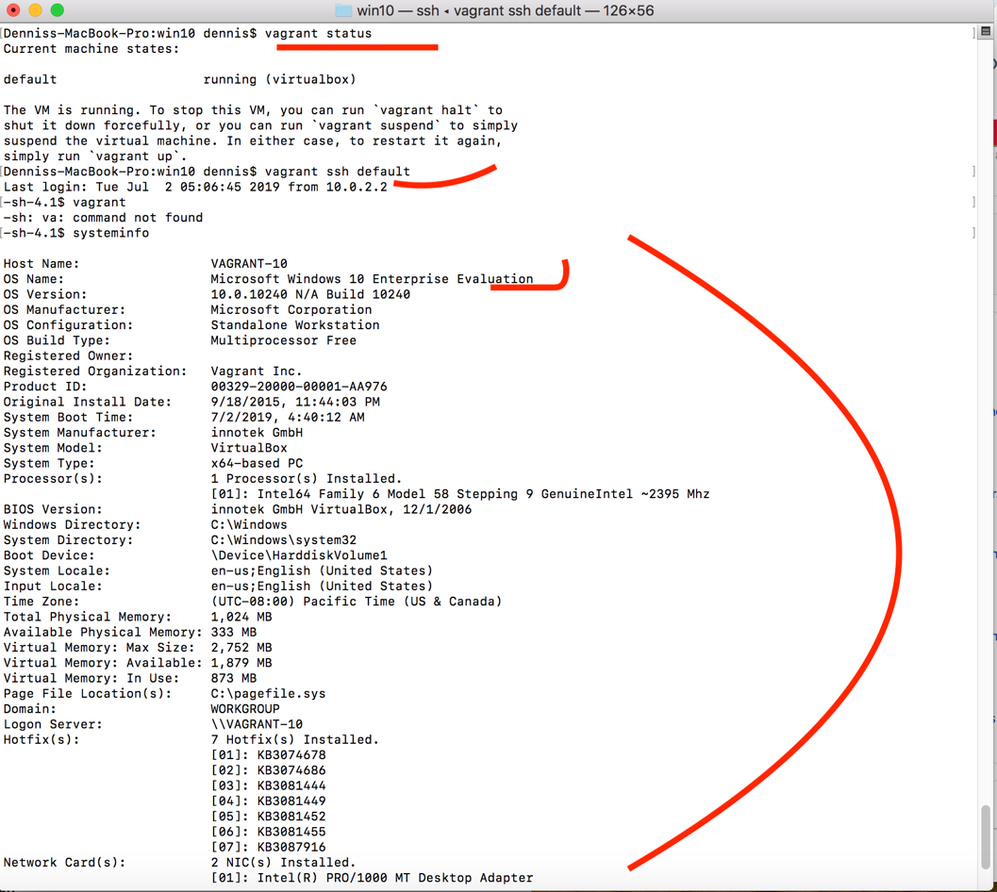

1.3.3. Remove box

vagrant halt default // gracefully stop VM (or --force)

vagrant destroy default //remove VM.I didn’t do it because downloading takes a long time

1.4. Create a multi-box configuration with a local network, using for three client VM boxes with Ubuntu 1804 and for a server – VM box with Windows 10

1.4.1. Using provisioning install MySQL Server in Windows OS and configure guest connection to MySQL Server using different usernames for client machines

msiexec /i mysql-installer-web-community-8.0.16.0.msi /passive

1.4.2. Using provisioning install MySQL Client in all Ubuntu OS and set up connections

1.4.3. Up all boxes with one command and connect via vagrant ssh to all boxes and check the connection of clients to the MySQL Server

1.4.4. Using vagrant install the JDK in Windows OS. After installation and configuration, view the java version.

1.4.5. Destroy via vagrant VM with Ubuntu

1.5. Create your own VagrantBox based on Ubuntu 1804

1.5.1. Based on the Ubuntu 1804 image, create a VM in VirtualBox

1.5.2. Install OpenJDK and configure on this VM

1.5.3. Install Intellij IDEA on this VM

1.5.4. Install MySQL Client

1.5.5. Make your own VagrantBox

1.5.6. Destroy VM Ubuntu 1804

1.5.7. From the box was created in section 1.5.5, create Vagrantfile with three machines and configure the local network

1.5.8. Check LAN connections

1.5.9. Check connection to MySQL server

2. Vagrant vs Hyper-V

2.1. Install Hyper-V

2.2. Install Vagrant

2.3. Create a Vagrantfile based on the box Windows 10

2.3.1. Up three Windows 10 with network settings

2.3.2. Connect to the box via vagrant ssh

2.3.3. Change the communicator to "winrm"

2.3.4. Connect to box via winrm. Check LAN connections.

2.3.5. Destroy box

2.4. Create a multi-box configuration with a local network, using for three client VM boxes with Windows 10 OS and for a server VM box with Ubuntu 1804 OS

2.4.1. Using provisioning in the Ubuntu OS, install MySQL Server and set up a guest connection to MySQL using different usernames for client machines

2.4.2. Using Windows provisioning, install the MySQL client and configure a guest connection to the MySQL server using different usernames for client machines.

2.4.3. Up all VM with one vagrant command.

2.4.4. Connect via vagrant ssh to server

2.4.5. Connect via "winrm" to client machines and check the connection of clients to the MySQL server

2.4.6. For all client machines using vagrant, install the JDK.

2.4.7. After installation and configuration, view the java version.

2.5. Create your own VagrantBox based on Windows 10 OS

2.5.1. Add Intellij IDEA to one of the Windows client machines created in section 2.4

2.5.2. Based on this VM, make your own VagrantBox

2.5.3. Destroy all Windows VMs with vagrant

2.5.4. Create a Vagrantfile to install three VMs with a configured LAN based on the OS created in section 2.5.2 and add a connection to the MySQL Server on the VM created in section 2.4.1

2.5.5. Up all VMs and check connection to MySQL Server from VMs with Windows OS 3. Create a report with screenshots and attach script files demonstrating the solution of the tasks